CO 1 AT-2
Name: P. Siddardha
Reg no: 192424271
14. Online Shopping Orders
Code:
import pandas as pd

# Read CSV file
df = pd.read_csv("orders.csv")

# Find duplicate Order IDs
print("Duplicate Orders:")
print(df[df.duplicated("OrderID", keep=False)])

# Remove duplicate orders
df = df.drop_duplicates("OrderID")

# Calculate Total Amount
df["TotalAmount"] = df["Quantity"] * df["Price"]

print("\nOrders:")
print(df)

# Total Sales
print("\nTotal Sales =", df["TotalAmount"].sum())

# Customer with Highest Purchase
customer = df.groupby("Customer")["TotalAmount"].sum()

print("\nHighest Purchase Customer:")
print(customer.idxmax(), "-", customer.max())

# Save cleaned file
df.to_csv("clean_orders.csv", index=False)

print("\nCleaned file saved")
OUTPUT:
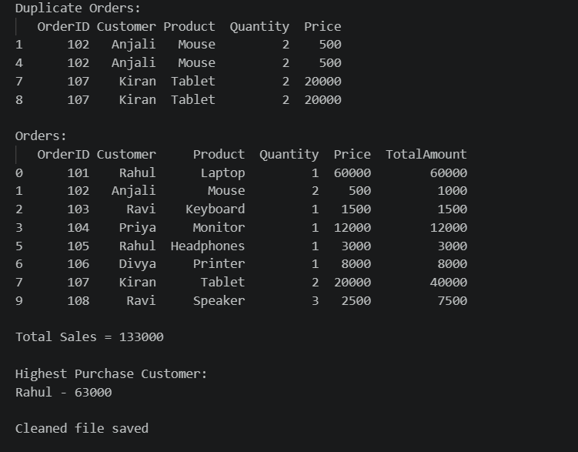

16. School Attendance System

Code:
import pandas as pd

# Read CSV file
df = pd.read_csv("attendance.csv")

# Calculate Attendance Percentage
df["AttendancePercentage"] = (df["ClassesAttended"] / df["TotalClasses"]) * 100

print("Attendance:")
print(df)

# Students below 75%
shortage = df[df["AttendancePercentage"] < 75]

print("\nStudents Below 75% Attendance:")
print(shortage)

# Save shortage list
shortage.to_csv("shortage_list.csv", index=False)

print("\nShortage list saved")
OUTPUT:
